Fundamentals of Relational Database Design

The Relational Model
The relational database model was conceived by E. F. Codd in 1969. The model is based on branches of mathematics called set theory and predicate logic. The basic idea behind the relational model is that a database consists of a series of unordered tables (or relations) that can be manipulated using non-procedural operations that return tables.
The relational model can be applied to both databases and database management systems (

Relational Database Design
When designing a database, you have to make decisions regarding how best to take some system in the real world and model it in a database. This consists of deciding which tables to create, what columns they will contain, as well as the relationships between the tables. While it would be nice if this process was totally intuitive and obvious, or even better automated, this is simply not the case. A well-designed database takes time and effort to conceive, build and refine.
The benefits of a database that has been designed according to the relational model are numerous. Some of them are:
- Data entry, updates and deletions will be efficient.
- Data retrieval, summarization and reporting will also be efficient.
- Since the database follows a well-formulated model, it behaves predictably.
- Since much of the information is stored in the database rather than in the application, the database is somewhat self-documenting.
- Changes to the database schema are easy to make.

Tables, Uniqueness and Keys
Tables in the relational model are used to represent "things" in the real world. Each table should represent only one thing. These things (or entities) can be real-world objects or events. For example, a real-world object might be a customer, an inventory item, or an invoice. Examples of events include patient visits, orders, and telephone calls. Tables are made up of rows and columns.
The relational model dictates that each row in a table be unique. If you allow duplicate rows in a table, then there's no way to uniquely address a given row via programming. This creates all sorts of ambiguities and problems that are best avoided. You guarantee uniqueness for a table by designating a primary key—a column that contains unique values for a table. Each table can have only one primary key, even though several columns or combination of columns may contain unique values. All columns (or combination of columns) in a table with unique values are referred to as candidate keys, from which the primary key must be drawn. All other candidate key columns are referred to as alternate keys. Keys can be simple or composite. A simple key is a key made up of one column, whereas a composite key is made up of two or more columns.
The decision as to which candidate key is the primary one rests in your hands—there's no absolute rule as to which candidate key is best. Fabian Pascal, in his book SQL and Relational Basics, notes that the decision should be based upon the principles of minimality (choose the fewest columns necessary), stability (choose a key that seldom changes), and simplicity/familiarity (choose a key that is both simple and familiar to users). Let's illustrate with an example. Say that a company has a table of customers called tblCustomer, which looks like the table shown in Figure 1.
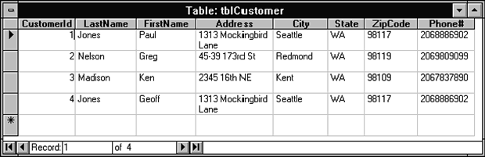
Figure 1. The best choice for primary key for tblCustomer would be CustomerId.
Candidate keys for tblCustomer might include CustomerId, (LastName + FirstName), Phone#, (Address, City, State), and (Address + ZipCode). Following Pascal's guidelines, you would rule out the last three candidates because addresses and phone numbers can change fairly frequently. The choice among CustomerId and the name composite key is less obvious and would involve tradeoffs.

Foreign Keys and Domains
Although primary keys are a function of individual tables, if you created databases that consisted of only independent and unrelated tables, you'd have little need for them. Primary keys become essential, however, when you start to create relationships that join together multiple tables in a database. A foreign key is a column in a table used to reference a primary key in another table.
Continuing the example presented in the last section, let's say that you choose CustomerId as the primary key for tblCustomer. Now define a second table, tblOrder, as shown in Figure 2.
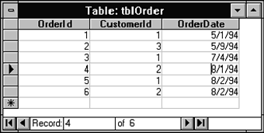
Figure 2. CustomerId is a foreign key in tblOrder which can be used to reference a customer stored in the tblCustomer table.
CustomerId is considered a foreign key in tblOrder since it can be used to refer to given customer (i.e., a row in the tblCustomer table).
It is important that both foreign keys and the primary keys that are used to reference share a common meaning and draw their values from the same domain. Domains are simply pools of values from which columns are drawn. For example, CustomerId is of the domain of valid customer ID #'s, which in this case might be Long Integers ranging between 1 and 50,000. Similarly, a column named Sex might be based on a one-letter domain equaling 'M' or 'F'. Domains can be thought of as user-defined column types whose definition implies certain rules that the columns must follow and certain operations that you can perform on those columns.

Relationships
You define foreign keys in a database to model relationships in the real world. Relationships between real-world entities can be quite complex, involving numerous entities each having multiple relationships with each other. For example, a family has multiple relationships between multiple people—all at the same time. In a relational database such as Microsoft Access, however, you consider only relationships between pairs of tables. These tables can be related in one of three different ways: one-to-one, one-to-many or many-to-many.

One-to-One Relationships
Two tables are related in a one-to-one (1—1) relationship if, for every row in the first table, there is at most one row in the second table. True one-to-one relationships seldom occur in the real world.
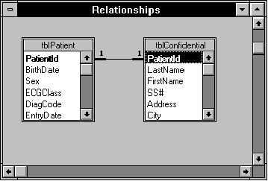
Figure 3. The tables tblPatient and tblConfidential are related in a one-to-one relationship. The primary key of both tables is PatientId.
Tables that are related in a one-to-one relationship should always have the same primary key, which will serve as the join column.

One-to-Many Relationships
Two tables are related in a one-to-many (1—M) relationship if for every row in the first table, there can be zero, one, or many rows in the second table, but for every row in the second table there is exactly one row in the first table. For example, each order for a pizza delivery business can have multiple items. Therefore, tblOrder is related to tblOrderDetails in a one-to-many relationship (see Figure 4). The one-to-many relationship is also referred to as a parent-child or master-detail relationship. One-to-many relationships are the most commonly modeled relationship.
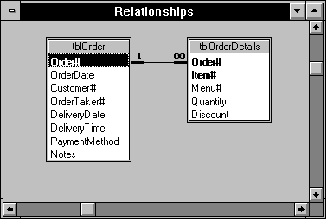
Figure 4. There can be many detail lines for each order in the pizza delivery business, so tblOrder and tblOrderDetails are related in a one-to-many relationship.
One-to-many relationships are also used to link base tables to information stored in lookup tables. For example, tblPatient might have a short one-letter DischargeDiagnosis code, which can be linked to a lookup table, tlkpDiagCode, to get more complete Diagnosis descriptions (stored in DiagnosisName). In this case, tlkpDiagCode is related to tblPatient in a one-to-many relationship (i.e., one row in the lookup table can be used in zero or more rows in the patient table).

Many-to-Many Relationships
Two tables are related in a many-to-many (M—M) relationship when for every row in the first table, there can be many rows in the second table, and for every row in the second table, there can be many rows in the first table. Many-to-many relationships can't be directly modeled in relational database programs. These types of relationships must be broken into multiple one-to-many relationships.

Normalization
As mentioned earlier in this article, when designing databases you are faced with a series of choices. How many tables will there be and what will they represent? Which columns will go in which tables? What will the relationships between the tables be? The answers each to these questions lies in something called normalization. Normalization is the process of simplifying the design of a database so that it achieves the optimum structure. Normalization is a method for organizing data elements in a database into tables. Normalization Avoids
- Duplication of Data – The same data is listed in multiple lines of the database
- Insert Anomaly – A record about an entity cannot be inserted into the table without first inserting information about another entity – Cannot enter a customer without a sales order
- Delete Anomaly – A record cannot be deleted without deleting a record about a related entity. Cannot delete a sales order without deleting all of the customer’s information.
- Update Anomaly – Cannot update information without changing information in many places. To update customer information, it must be updated for each sales order the customer has placed
Normalization theory gives us the concept of normal forms to assist in achieving the optimum structure. The normal forms are a linear progression of rules that you apply to your database, with each higher normal form achieving a better, more efficient design. The normal forms are:
- First Normal Form (1НФ)
- Second Normal Form (2НФ)
- Third Normal Form (3НФ)
- Boyce Codd Normal Form (НФБК)
- Fourth Normal Form (4НФ)
- Fifth Normal Form (5НФ)
Normalization is a three stage process – After the first stage, the data is said to be in first normal form, after the second, it is in second normal form, after the third, it is in third normal form. 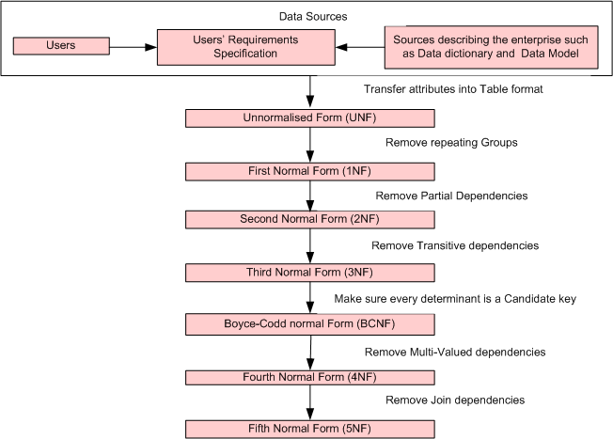

Functional Dependencies are fundamental to the process of Normalization Functional Dependency describes the relationship between attributes(columns) in a table.
For example, if A and B are attributes of a table, B is functionally dependent on A, if each value of A is associated with exactly one value of B (so, you can say, 'A functionally determines B').

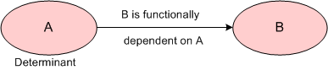
Functional dependency between A and B

Definition: A functional dependency occurs when one attribute in a relation uniquely determines another attribute. This can be written A -> B which would be the same as stating "B is functionally dependent upon A."Attributes A and B may be composite.
Functional Dependency can be classified as follows:
- Full Functional dependency Indicates that if A and B are attributes(columns)of a table, B is fully functionally dependent on A if B is functionally dependent on A ,but not on any proper subset of A.
- Partial Functional Dependency Indicates that if A and B are attributes of a table , B is partially dependent on A if there is some attribute that can be removed from A and yet the dependency still holds.
Say for Ex, consider the following functional dependency that exists in the Tbl_Staff table:
Transitive Functional Dependency: A condition where A , B and C are attributes of a table such that if A is functionally dependent on B and B is functionally dependent on C then C is Transitively dependent on A via B.
Armstrongs Axioms
A (universal) relation U is used. Let’s R (X,Y) is a relation
1. Reflexivity Rule
If Y ⊆ X
Then X -> Y holds for all X,Y ⊆ U
2. Augmentation Rule
If X->Y and Z ⊆ U
Then Zx -> Zy for all X,Y ⊆ U

3. Transitivity Rule
If X-> Y and Y-> Z then X-> Z for X,Y,Z ⊆ U
Additional rules (which can be derived from above axioms)
4. Union Rule
If X-> Y and X-> Z then X-> YZ
5. Decomposition Rule
If X-> YZ then X-> Y and X-> Z
6. Pseudo Transitivity Rules
If X-> Y and TY -> Z then TX -> Z

Before First Normal Form: Relations

Before Normalization
- Begin with a list of all of the fields that must appear in the database. Think of this as one big table.
- Do not include computed fields
- One place to begin getting this information is from a printed document used by the system.
- Additional attributes besides those for the entities described on the document can be added to the database.

Example
See Sales Order from below:
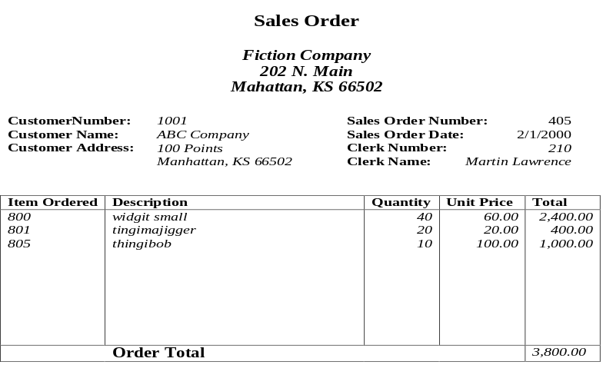

The Normal Forms are based on relations rather than tables. A relation is a special type of table that has the following attributes:
- They describe one entity.
- They have no duplicate rows; hence there is always a primary key.
- The columns are unordered.
- The rows are unordered.

First Normal Form

First Normal Form (1NF) says that all column values must be atomic.
The word atom comes from the Latin atomis, meaning indivisible (or literally "not to cut"). 1NF dictates that, for every row-by-column position in a given table, there exists only one value, not an array or list of values. The benefits from this rule should be fairly obvious. If lists of values are stored in a single column, there is no simple way to manipulate those values. Retrieval of data becomes much more laborious and difficult to generalize. For example, the table in Figure 6, tblOrder1, used to store order records for a hardware store, would violate 1NF:
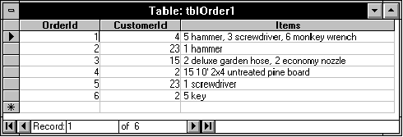
Figure 6. tblOrder1 violates First Normal Form because the data stored in the Items column is not atomic.
You'd have a difficult time retrieving information from this table, because too much information is being stored in the Items field. Think how difficult it would be to create a report that summarized purchases by item.
1NF also prohibits the presence of repeating groups, even if they are stored in composite (multiple) columns. For example, the same table might be improved upon by replacing the single Items column with six columns: Quant1, Item1, Quant2, Item2, Quant3, Item3 (see Figure 7).
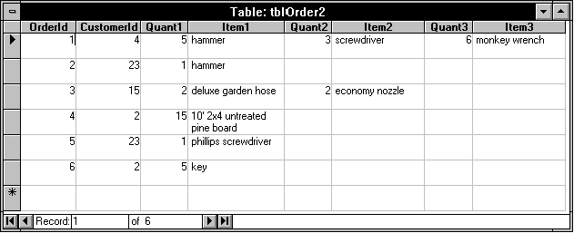
Figure 7. A better, but still flawed, version of the Orders table, tblOrder2. The repeating groups of information violate First Normal Form.
While this design has divided the information into multiple fields, it's still problematic. For example, how would you go about determining the quantity of hammers ordered by all customers during a particular month? Any query would have to search all three Item columns to determine if a hammer was purchased and then sum over the three quantity columns. Even worse, what if a customer ordered more than three items in a single order? You could always add additional columns, but where would you stop? Ten items, twenty items? Say that you decided that a customer would never order more than twenty-five items in any one order and designed the table accordingly. That means you would be using 50 columns to store the item and quantity information per record, even for orders that only involved one or two items. Clearly this is a waste of space. And someday, someone would want to order more than 25 items.
Tables in 1NF do not have the problems of tables containing repeating groups. The table in Figure 8, tblOrder3, is 1NF since each column contains one value and there are no repeating groups of columns. In order to attain 1NF, I have added a column, OrderItem#. The primary key of this table is a composite key made up of OrderId and OrderItem#.
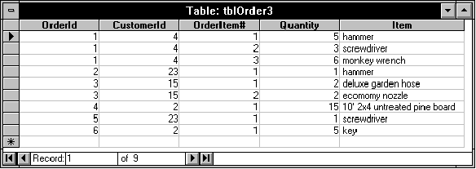
Figure 8. The tblOrder3 table is in First Normal Form.

Second Normal Form

A table is said to be in Second Normal Form (2NF), if it is in 1NF and every non-key column is fully dependent on the (entire) primary key.
Put another way, tables should only store data relating to one "thing" (or entity) and that entity should be described by its primary key.
The table shown in Figure 10, tblOrder4, is slightly modified version of tblOrder3. Like tblOrder3, tblOrder4 is in First Normal Form. Each column is atomic, and there are no repeating groups.
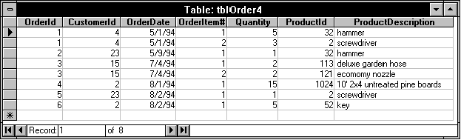
Figure 10. The tblOrder4 table is in First Normal Form. Its primary key is a composite of OrderId and OrderItem#.
To determine if tblOrder4 meets 2NF, you must first note its primary key. The primary key is a composite of OrderId and OrderItem#. Thus, in order to be 2NF, each non-key column (i.e., every column other than OrderId and OrderItem#) must be fully dependent on the primary key. In other words, does the value of OrderId and OrderItem# for a given record imply the value of every other column in the table? The answer is no. Given the OrderId, you know the customer and date of the order, without having to know the OrderItem#. Thus, these two columns are not dependent on the entire primary key which is composed of both OrderId and OrderItem#. For this reason tblOrder4 is not 2NF.
You can achieve Second Normal Form by breaking tblOrder4 into two tables. The process of breaking a non-normalized table into its normalized parts is called decomposition. Since tblOrder4 has a composite primary key, the decomposition process is straightforward. Simply put everything that applies to each order in one table and everything that applies to each order item in a second table. The two decomposed tables, tblOrder and tblOrderDetail, are shown in Figure 11.
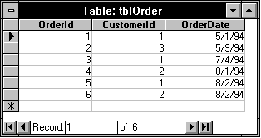
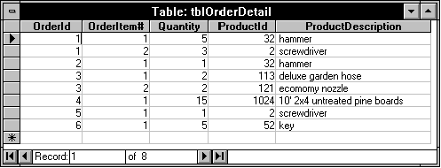
Figure 11. The tblOrder and tblOrderDetail tables satisfy Second Normal Form. OrderId is a foreign key in tblOrderDetail that you can use to rejoin the tables.
Two points are worth noting here.
- When normalizing, you don't throw away information. In fact, this form of decomposition is termed non-loss decomposition because no information is sacrificed to the normalization process.
- You decompose the tables in such a way as to allow them to be put back together again using queries. Thus, it's important to make sure that tblOrderDetail contains a foreign key to tblOrder. The foreign key in this case is OrderId which appears in both tables.

What if we did not Normalize the Database to Second Normal Form?
- Repetition of Data – Description would appear every time we had an order for the item
- Delete Anomalies –
- Insert Anomalies –
- Update Anomalies
An Anomaly is simply an error or inconsistency in the database. A poorly designed database runs the risk of introducing numerous anomalies. There are three types of anomalies:
- Insertion: an anomaly that occurs during the insertion of a record. For example, the insertion of a new row causes a calculated total field stored in another table to report the wrong total.
- Deletion: an anomaly that occurs during the deletion of a record. For example, the deletion of a row in the database deletes more information than you wished to delete.
- Update: an anomaly that occurs during the updating of a record. For example, updating a description column for a single part in an inventory database requires you to make a change to thousands of rows.

Third Normal Form

A table is said to be in Third Normal Form (3NF), if it is in 2NF and if all non-key columns are mutually independent.
An obvious example of a dependency is a calculated column. For example, if a table contains the columns Quantity and PerItemCost, you could opt to calculate and store in that same table a TotalCost column (which would be equal to Quantity*PerItemCost), but this table wouldn't be 3NF. It's better to leave this column out of the table and make the calculation in a query or on a form or a report instead. This saves room in the database and avoids having to update TotalCost, every time Quantity or PerItemCost changes.
The tblOrderDetail table can be further decomposed to achieve 3NF by breaking out the ProductId—ProductDescription dependency into a lookup table as shown in Figure 12. This gives you a new order detail table, tblOrderDetail1 and a lookup table, tblProduct. When decomposing tblOrderDetail, take care to put a copy of the linking column, in this case ProductId, in both tables. ProductId becomes the primary key of the new table, tblProduct, and becomes a foreign key column in tblOrderDetail1. This allows you to easily join together the two tables using a query.
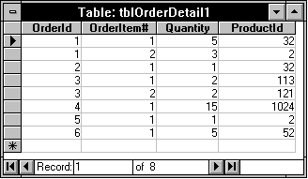
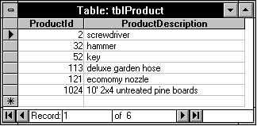
Figure 12. The tbOrderDetail1 and tblProduct tables are in Third Normal Form. The ProductId column in tblOrderDetail1 is a foreign key referencing tblProduct.

Higher Normal Forms
After Codd defined the original set of normal forms it was discovered that Third Normal Form, as originally defined, had certain inadequacies. This led to several higher normal forms, including the Boyce/Codd, Fourth and Fifth Normal Forms. I will not be covering these higher normal forms, instead, several points are worth noting here:
- Every higher normal form is a superset of all lower forms. Thus, if your design is in Third Normal Form, by definition it is also in 1NF and 2NF.
- If you've normalized your database to 3NF, you've likely also achieved Boyce/Codd Normal Form (and maybe even 4NF or 5NF).
- To quote C.J. Date, the principles of database design are "nothing more than formalized common sense."
- Database design is more art than science.
This last item needs to be emphasized. While it's relatively easy to work through the examples in this article, the process gets more difficult when you are presented with a business problem (or another scenario) that needs to be computerized (or downsized). I have outlined an approach to take later in this article, but first the subject of integrity rules will be discussed.

Normalization: Third Normal Form
- Remove transitive dependencies.
- Transitive Dependency A type of functional dependency where an attribute is functionally dependent on an attribute other than the primary key. Thus its value is only indirectly determined by the primary key.
- Create a separate table containing the attribute and the fields that are functionally dependent on it. Tables created at this step will usually contain descriptions of either resources or agents. Keep a copy of the key attribute in the original file.
Decomposition
Let R be a relation schema.
A set of relation schemas is a decomposition of R if

Integrity Rules
The relational model defines several integrity rules that, while not part of the definition of the Normal Forms are nonetheless a necessary part of any relational database. There are two types of integrity rules: general and database-specific.

General Integrity Rules
The relational model specifies two general integrity rules. They are referred to as general rules, because they apply to all databases. They are: entity integrity and referential integrity.
The entity integrity rule is very simple. It says that primary keys cannot contain null (missing) data. The reason for this rule should be obvious. You can't uniquely identify or reference a row in a table, if the primary key of that table can be null. It's important to note that this rule applies to both simple and composite keys. For composite keys, none of the individual columns can be null. Fortunately, Microsoft Access automatically enforces the entity integrity rule for you. No component of a primary key in Microsoft Access can be null.
The referential integrity rule says that the database must not contain any unmatched foreign key values. This implies that:
- A row may not be added to a table with a foreign key unless the referenced value exists in the referenced table.
- If the value in a table that's referenced by a foreign key is changed (or the entire row is deleted), the rows in the table with the foreign key must not be "orphaned."
In general, there are three options available when a referenced primary key value changes or a row is deleted. The options are:
- Disallow. The change is completely disallowed.
- Cascade. For updates, the change is cascaded to all dependent tables. For deletions, the rows in all dependent tables are deleted.
- Nullify. For deletions, the dependent foreign key values are set to Null.
Microsoft Access allows you to disallow or cascade referential integrity updates and deletions using the Edit | Relationships command (see Figure 13). Nullify is not an option.
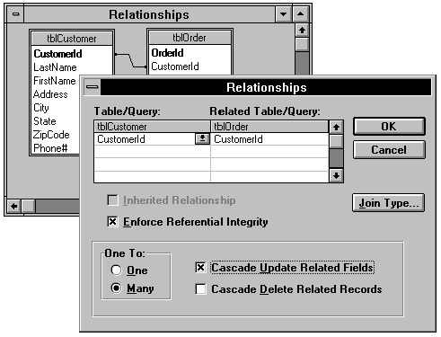
Figure 13. Specifying a relationship with referential integrity between the tblCustomer and tblOrder tables using the Edit | Relationships command. Updates of CustomerId in tblCustomer will be cascaded to tblOrder. Deletions of rows in tblCustomer will be disallowed if rows in tblOrders would be orphaned.
Note: When you wish to implement referential integrity in Microsoft Access, you must perform one additional step outside of the Edit | Relationships dialog: in table design, you must set the Required property for the foreign key column to Yes. Otherwise, Microsoft Access will allow your users to enter a Null foreign key value, thus violating strict referential integrity.

Database-Specific Integrity Rules
All integrity constraints that do not fall under entity integrity or referential integrity are termed database-specific rules or business rules. These type of rules are specific to each database and come from the rules of the business being modeled by the database. It is important to note that the enforcement of business rules is as important as the enforcement of the general integrity rules discussed in the previous section.
Note: Rules in Microsoft Access 2.0 are now enforced at the engine level, which means that forms, action queries and table imports can no longer ignore your rules. Because of this change, however, column rules can no longer reference other columns or use domain, aggregate, or user-defined functions.
Without the specification and enforcement of business rules, bad data will get in the database. The old adage, "garbage in, garbage out" applies aptly to the application (or lack of application) of business rules. For example, a pizza delivery business might have the following rules that would need to be modeled in the database:
- Order date must always be between the date the business started and the current date.
- Order time and delivery time can be only during business hours.
- Delivery time must be greater than or equal to Order time.
- New orders cannot be created for discontinued menu items.
- Customer zip codes must be within a certain range—the delivery area.
- The quantity ordered can never be less than 1 or greater than 50.
- Non-null discounts can never be less than 1 percent or greater than 30 percent.
Microsoft Access 2.0 supports the specification of validation rules for each column in a table. For example, the first business rule from the above list has been specified in Figure 14.
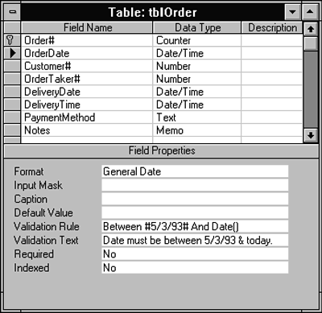
Figure 14. A column validation rule has been created to limit all order dates to some time between the first operating day of the business (5/3/93) and the current date.
Microsoft Access 2.0 also supports the specification of a global rule that applies to the entire table. This is useful for creating rules that cross-reference columns as the example in Figure 15 demonstrates. Unfortunately, you're only allowed to create one global rule per table, which could make for some awful validation error messages (e.g., "You have violated one of the following rules: 1. Delivery Date > Order Date. 2. Delivery Time > Order Time....").
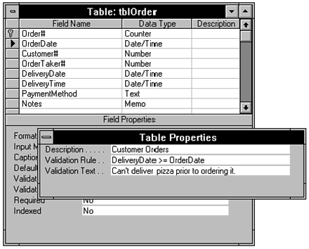
Figure 15. A table validation rule has been created to require that deliveries be made on or after the date the pizza was ordered.
Although Microsoft Access business-rule support is better than most other desktop DBMS programs, it is still limited (especially the limitation of one global table rule), so you will typically build additional business rule logic into applications, usually in the data entry forms. This logic should be layered on top of any table-based rules and can be built into the application using combo boxes, list-boxes and option groups that limit available choices, form-level and field-level validation rules, and event procedures. These application-based rules, however, should be used only when the table-based rules cannot do the job. The more you can build business rules in at the table level, the better, because these rules will always be enforced and will require less maintenance.

A Practical Approach to Database Design
As mentioned earlier in this article, database design is more art than science. While it's true that a properly designed database should follow the normal forms and the relational model, you still have to come up with a design that reflects the business you are trying to model. Relational database design theory can usually tell you what not to do, but it won't tell you where to start or how to manage your business. This is where it helps to understand the business (or other scenario) you are trying to model. A well-designed database requires business insight, time, and experience. Above all, it shouldn't be rushed.
To assist you in the creation of databases, I've outlined the following 20-step approach to sound database design:
- Take some time to learn the business (or other system) you are trying to model. This will usually involve sitting down and meeting with the people who will be using the system and asking them lots of questions.
- On paper, write out a basic mission statement for the system. For example, you might write something like "This system will be used to take orders from customers and track orders for accounting and inventory purposes." In addition, list out the requirements of the system. These requirements will guide you in creating the database schema and business rules. For example, create a list that includes entries such as "Must be able to track customer address for subsequent direct mail."
- Start to rough out (on paper) the data entry forms. (If rules come to mind as you lay out the tables, add them to the list of requirements outlined in step 2.) The specific approach you take will be guided by the state of any existing system.
  - If this system was never before computerized, take the existing paper-based system and rough out the table design based on these forms. It's very likely that these forms will be non-normalized.
  - If the database will be converted from an existing computerized system, use its tables as a starting point. Remember, however, that it's very likely that the existing schema will be non-normalized. It's much easier to normalize the database now rather than later. Print out the existing schema, table by table, and the existing data entry forms to use in the design process.
  - If you are really starting from scratch (e.g., for a brand new business), then rough out on paper what forms you envision filling out.
- Based on the forms, you created in step 3, rough out your tables on paper. If normalization doesn't come naturally (or from experience), you can start by creating one huge, non-normalized table per form that you will later normalize. If you're comfortable with normalization theory, try and keep it in mind as you create your tables, remembering that each table should describe a single entity.
- Look at your existing paper or computerized reports. (If you're starting from scratch, rough out the types of reports you'd like to see on paper.) For existing systems that aren't currently meeting the user needs, it's likely that key reports are missing. Create them now on paper.
- Take the roughed-out reports from step 5 and make sure that the tables from step 4 include this data. If information is not being collected, add it to the existing tables or create new ones.
- On paper, add several rows to each roughed-out table. Use real data if at all possible.
- Start the normalization process. First, identify candidate keys for every table and using the candidates, choose the primary key. Remember to choose a primary key that is minimal, stable, simple, and familiar. Every table must have a primary key! Make sure that the primary key will guard against all present and future duplicate entries.
- Note foreign keys, adding them if necessary to related tables. Draw relationships between the tables, noting if they are one-to-one or one-to-many. If they are many-to-many, then create linking tables.
- Determine whether the tables are in First Normal Form. Are all fields atomic? Are there any repeating groups? Decompose if necessary to meet 1NF.
- Determine whether the tables are in Second Normal Form. Does each table describe a single entity? Are all non-key columns fully dependent on the primary key? Put another way, does the primary key imply all of the other columns in each table? Decompose to meet 2NF. If the table has a composite primary key, then the decomposition should, in general, be guided by breaking the key apart and putting all columns pertaining to each component of the primary key in their own tables.
- Determine if the tables are in Third Normal Form. Are there any computed columns? Are there any mutually dependent non-key columns? Remove computed columns. Eliminate mutual dependent columns by breaking out lookup tables.
- Using the normalized tables from step 12, refine the relationships between the tables.
- Create the tables using Microsoft Access (or whatever database program you are using). If using Microsoft Access, create the relationships between the tables using the Edit | Relationships command. Add sample data to the tables.
- Create prototype queries, forms, and reports. While creating these objects, design deficiencies should become obvious. Refine the design as needed.
- Bring the users back in. Have them evaluate your forms and reports. Are their needs met? If not, refine the design. Remember to re-normalize if necessary (steps 8-12).
- Go back to the table design screen and add business rules.
- Create the final forms, reports, and queries. Develop the application. Refine the design as necessary.
- Have the users test the system. Refine the design as needed.
- Deliver the final system.
This list doesn't cover every facet of the design process, but it's useful as a framework for the process.

Breaking the Rules: When to Denormalize
Sometimes it's necessary to break the rules of normalization and create a database that is deliberately less normal than it otherwise could be. You'll usually do this for performance reasons or because the users of the database demand it. While this won't get you any points with database design purists, ultimately you have to deliver a solution that satisfies your users. If you do break the rules, however, and decide to denormalize you database, it's important that you follow these guidelines:
- Break the rules deliberately; have a good reason for denormalizing.
- Be fully aware of the tradeoffs this decision entails.
- Thoroughly document this decision.
- Create the necessary application adjustments to avoid anomalies.
This last point is worth elaborating on. In most cases, when you denormalize, you will be required to create additional application code to avoid insertion, update, and deletion anomalies that a more normalized design would avoid. For example, if you decide to store a calculation in a table, you'll need to create extra event procedure code and attach it to the appropriate event properties of forms that are used to update the data on which the calculation is based.
If you're considering denormalizing for performance reasons, don't always assume that the denormalized approach is the best. Instead, I suggest you first fully normalize the database (to Third Normal Form or higher) and then denormalize only if it becomes necessary for reasons of performance.
If you're considering denormalizing because your users think they need it, investigate why. Often they will be concerned about simplifying data entry, which you can usually accomplish by basing forms on queries while keeping your base tables fully normalized.
Here are several scenarios where you might choose to break the rules of normalization:
- You decide to store an indexed computed column, Soundex, in tblCustomer to improve query performance, in violation of 3NF (because Soundex is dependent on LastName). The Soundex column contains the sound-alike code for the LastName column. It's an indexed column (with duplicates allowed) and is calculated using a user-defined function. If you wish to perform searches on the Soundex column with any but the smallest tables, you'll find a significant performance advantage to storing the Soundex column in the table and indexing this computed column. You'd likely use an event procedure attached to a form to perform the Soundex calculation and store the result in the Soundex column. To avoid update anomalies, you'll want to ensure that this column cannot be updated by the user and that it is updated every time LastName changes.
- In order to improve report performance, you decide to create a column named TotalOrderCost that contains a sum of the cost of each order item in tblOrder. This violates 2NF because TotalOrderCost is dependent on the primary key of tblOrderDetail, not on tblOrder's primary key. TotalOrderCost is calculated on a form by summing the column TotalCost for each item. Since you often create reports that need to include the total order cost, but not the cost of individual items, you've broken 2NF to avoid having to join these two tables every time this report needs to be generated. As in the last example, you have to be careful to avoid update anomalies. Whenever a record in tblOrderDetail is inserted, updated, or deleted, you will need to update tblOrder, or the information stored there will be erroneous.
- You decide to include a column, SalesPerson, in the tblInvoice table, even though SalesId is also included in tblInvoice. This violates 3NF because the two non-key columns are mutually dependent, but it significantly improves the performance of certain commonly run reports. Once again, this is done to avoid a join to the tblEmployee table, but introduces redundancies and adds the risk of update anomalies.

Summary
This article has covered the basics of database design in the context of Microsoft Access. The main concepts covered were:
- The relational database model was created by E.F. Codd in 1969 and is founded on set theory and logic.
- A database designed according to the relational model will be efficient, predictable, well performing, self-documenting and easy to modify.
- Every table must have a primary key, which uniquely identifies rows in the table.
- Foreign keys are columns used to reference a primary key in another table.
- You can establish three kinds of relationships between tables in a relational database: one-to-one, one-to-many or many-to-many. Many-to-many relationships require a linking table.
- Normalization is the process of simplifying the design of a database so that it achieves the optimum structure.
- A well-designed database follows the Normal Forms.
- The entity integrity rule forbids nulls in primary key columns.
- The referential integrity rule says that the database must not contain any unmatched foreign key values.
- Business rules are an important part of database integrity.
- A well-designed database requires business insight, time, and experience.
- Occasionally, you made need to denormalize for performance.
Database design is an important component of application design. If you take the time to design your databases properly, you'll be rewarded with a solid application foundation on which you can build the rest of your application.

